CN Lab 3
Wireshark Document
Vishal Puneyani (CSE – A) : 210905037

UDP PACKET ANALYSIS

A.
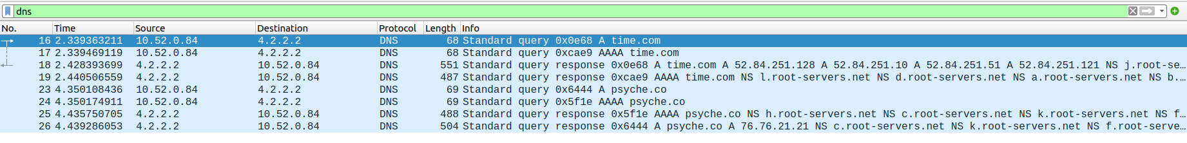
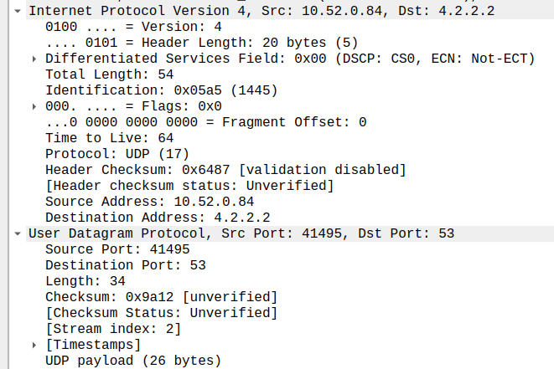
DNS Query Packet 16

- Source port number : 41495
- Destination port number : 53
- Length of user datagram : 34 bytes
- Length of data : 68 bytes
- Packet directed from Client to Server as Source IP is of user’s laptop and Destination IP is of server.
- Application layer protocol : DNS
- Checksum status unverified (0x9a12)

B.
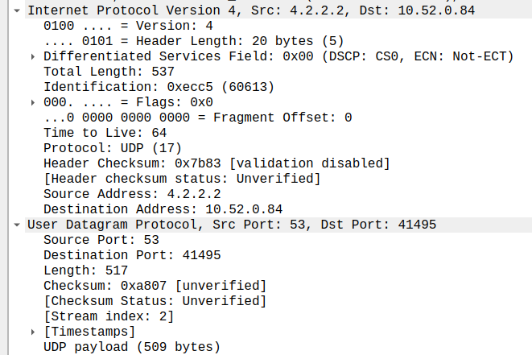
DNS response packet 18

Source IP (Query) : 10.52.0.84
Destination IP (Query) : 4.2.2.2

Source IP (Response) : 4.2.2.2
Destination IP (Response) : 10.52.0.84

IP addresses are reversed for source and destination in the query and response.

C.
Source Port (Query) : 41495
Destination Port (Query) : 53

Source Port (Response) : 53
Destination Port (Response) : 41495

Port numbers are also reversed for source and destination in query and response.

Well-known port number is 53.

D.
Length of packet : 68 bytes
Payload size : 26 bytes

TCP PACKET ANALYSIS

Part 1- Connection Establishment

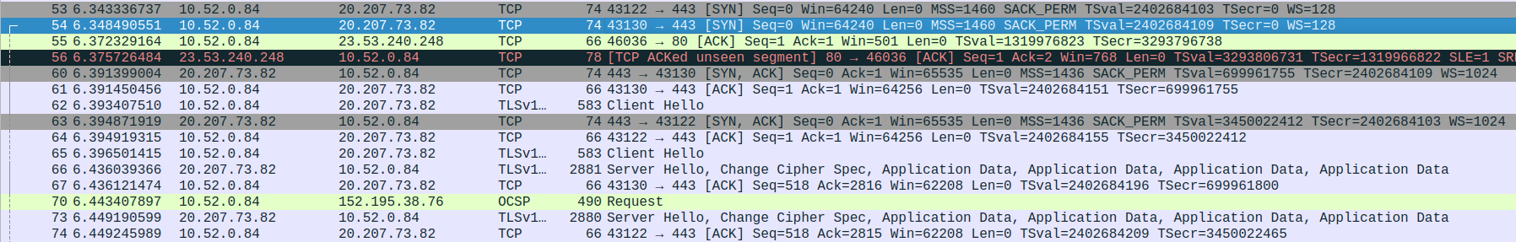
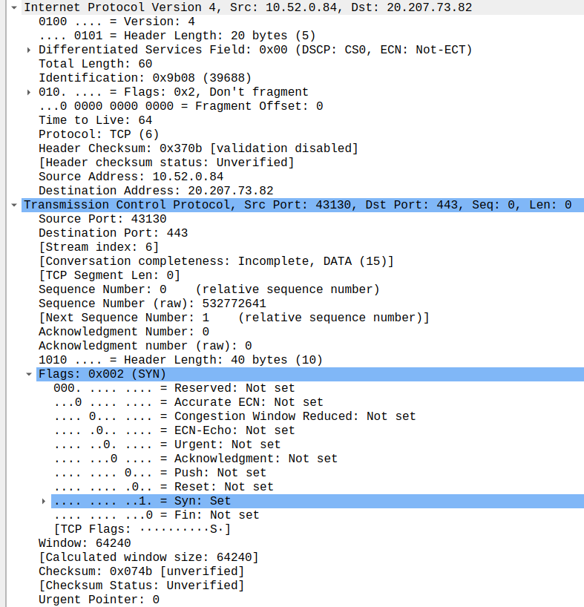
SYN Packet 1
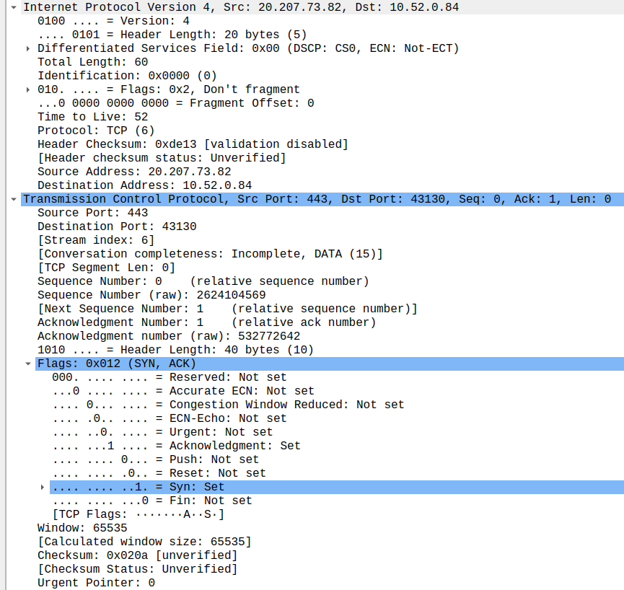

SYN,ACK Packet 2

ACK Packet 3

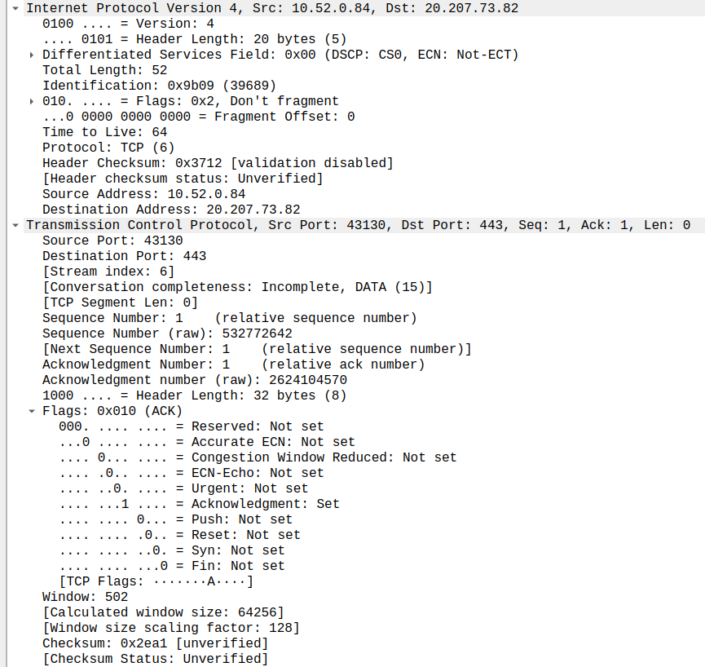
1. Socket addresses for :

Packet 1 : Source IP : 10.52.0.84 | PORT – 43130
Destination IP : 20.207.73.82 | PORT – 433

Packet 2 : Destination IP : 10.52.0.84 | PORT – 43130
Source IP : 20.207.73.82 | PORT – 433

Packet 3 : Source IP : 10.52.0.84 | PORT – 43130
Destination IP : 20.207.73.82 | PORT – 433

2. Flags for each packet

Packet 1 : 0x002 (SYN)
Packet 2 : 0x012 (SYN,ACK)
Packet 3 : 0x010 (ACK)
3. Sequence and Acknowledgement number

Packet 1 : 532772641 and 0
Packet 2 : 2624104569 and 532772642
Packet 3 : 532772642 and 2624104570

4. Window size of packets

Packet 1 : 62420
Packet 2 : 65535
Packet 3 : 502

Part 2 – Data Transfer

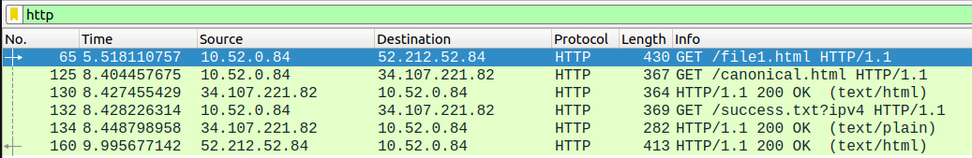

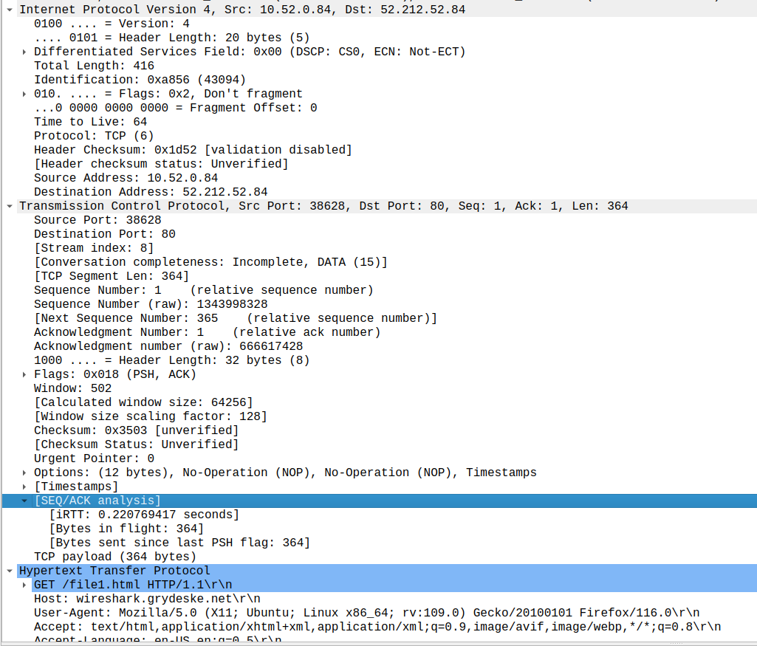
HTTP GET Request Packet
HTTP OK Packet
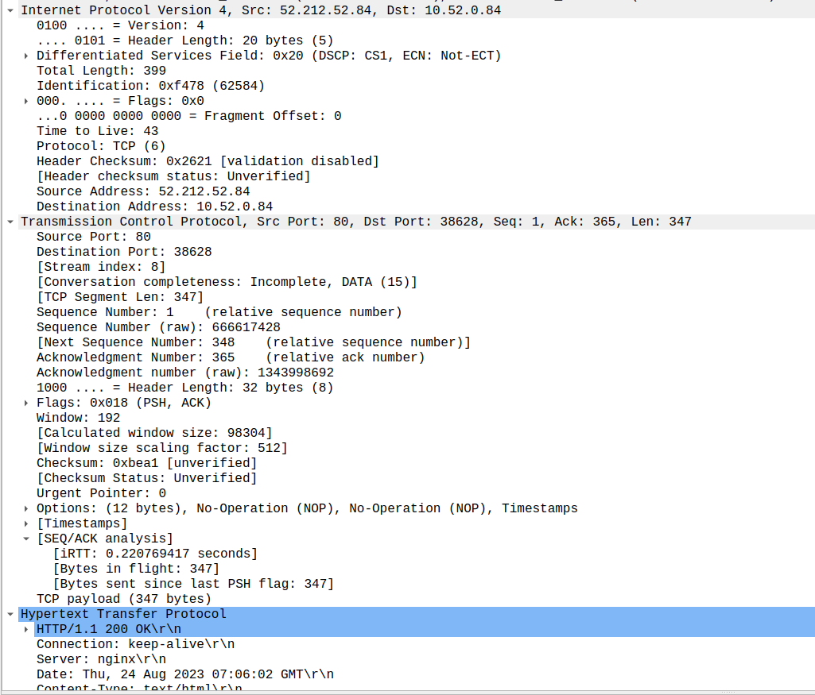

- Flags for GET : 0x018 (PSH,ACK)
- 416 bytes transmitted
- 4.477568365 seconds
- 4
- 5
- 6
- 7

Part 3 – Connection Termination

Packet 1 for termination

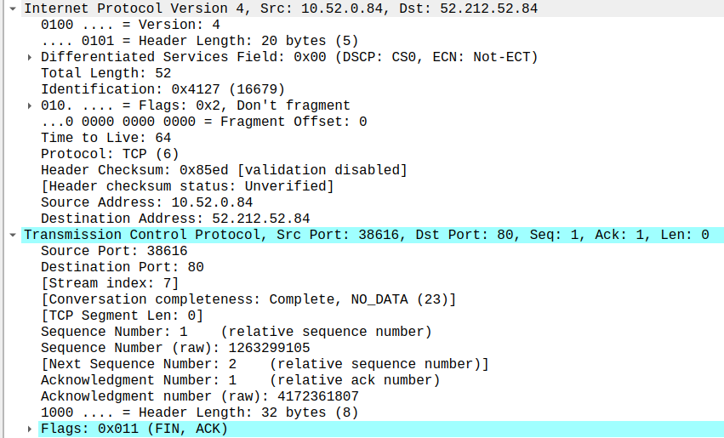

Packet 2 for termination
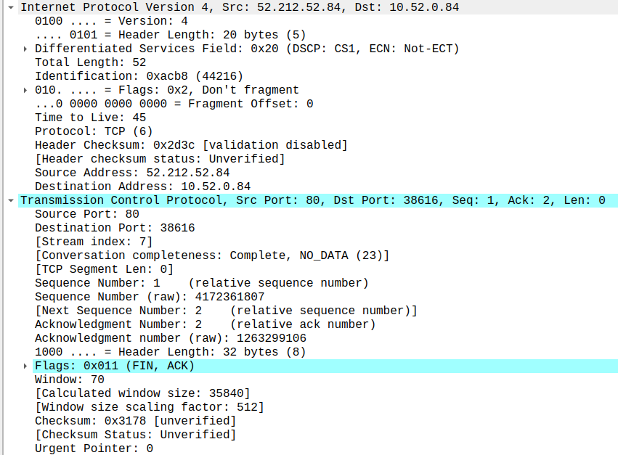

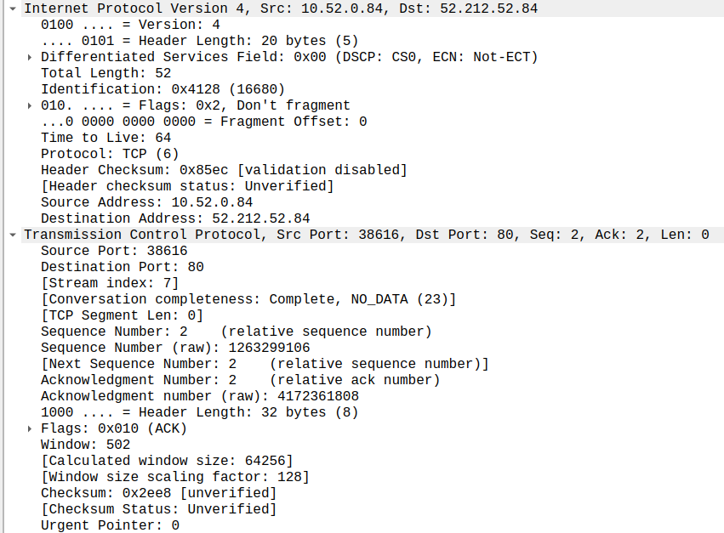
Packet 3 for termination

